Term Project Report: Spatial Inequalities in Emergency Medical Services Response Times in New York City - Qianchen Yu, Jia Johnson, & Yuanseng Choo

Introduction:
Timely access to emergency medical services (EMS) is a critical component of urban health and safety systems, and response time is one of the most visible and consequential performance metrics. When residents dial 911, they not only expect clinical quality, they also expect the ambulance to arrive quickly enough to make a difference for strokes, cardiac events, and other time-sensitive emergencies. And because EMS is often the public face of emergency care, persistent delays can erode trust and amplify existing concerns about inequity in city services.
However, EMS response times are rarely uniform across a city. Instead, they often exhibit systematic disparities between neighborhoods that raise questions about fairness and access to timely care. Some communities face both higher EMS demand and slower average response, while others benefit from faster service even at similar or lower levels of need. These inequalities are not only operational issues about where to place ambulances or how to route vehicles; they are also spatial inequalities that intersect with patterns of race, income, and housing. Therefore, understanding where slow responses are concentrated and which neighborhood characteristics are associated with delays is essential for both system design and health equity.
New York City offers a particularly compelling context for examining these disparities because it combines high volumes of EMS demand with sharp socioeconomic and racial inequalities across ZIP codes. The city’s EMS system responds to a large number of incidents each year, and these calls are recorded with detailed time stamps and location information. At the same time, the American Community Survey (ACS) provides rich ZIP-code-level indicators on poverty, unemployment, education, renter share, and race and ethnicity. By integrating EMS dispatch data from 2019 to 2024 with ACS 2022 ZIP-code indicators, we are able to construct a spatially explicit dataset that links response times to neighborhood context across the entire city. Figure 1 shows that EMS incident volume and average response times vary substantially across New York City ZIP codes, with clear concentrations of high demand and slower response in certain parts of the city.
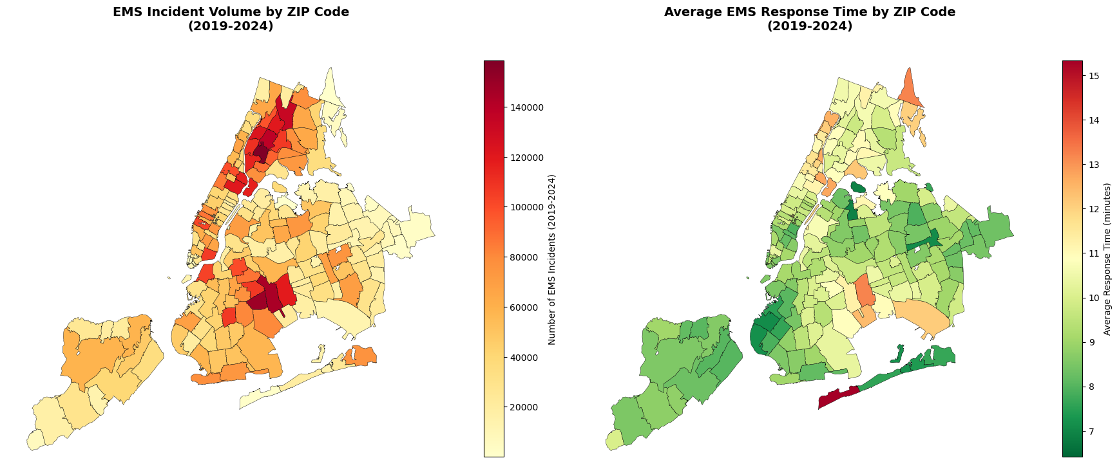
Figure 1. Spatial distribution of EMS incident volume (a) and average response time (b) across New York City ZIP codes, 2019–2024
Despite extensive operational research on EMS deployment and average response times, far fewer studies explicitly integrate spatial statistics, neighborhood sociodemographic indicators, and machine-learning models to assess equity in urban EMS performance. Traditional work often focuses on optimizing station locations, fleet size, or routing policies to reduce mean response time at the citywide level. These studies are valuable, and they provide critical insights for system efficiency. However, they often treat demand and response time as aggregate quantities, without fully interrogating how delays may cluster in specific neighborhoods or how these clusters align with poverty, race, and housing conditions. Therefore, a more equity-oriented, spatially explicit approach is needed to complement the existing efficiency-focused literature.
To address this gap, this study combines New York City EMS dispatch records from 2019–2024 with 2022 ACS ZIP-code data to analyze spatial patterns, neighborhood correlates, and predictive models of slow EMS response. We first use spatial statistics, including Moran’s I and local indicators of spatial association (LISA), to detect clusters of EMS demand, response times, and socioeconomic disadvantage across ZIP codes. We then estimate a logistic regression model and train tree-based classifiers to predict whether a ZIP code will have an average EMS response time greater than 10 minutes, and to examine the relative importance of socioeconomic, racial, housing, and demand-related features. Guided by this framework, we address three research questions: (1) What spatial patterns and clusters of EMS demand and response times emerge across New York City ZIP codes? (RQ1); (2) How are slow-response ZIP codes related to neighborhood socioeconomic and racial composition? (RQ2); and (3) To what extent can machine-learning models help predict “slow-response” ZIP codes and identify the most important predictors? (RQ3). Therefore, our contribution is to provide a data-driven, spatially explicit framework that helps identify and prioritize high-risk, highly vulnerable neighborhoods for EMS planning and equity-oriented resource allocation in New York City.

Data Cleaning and Preparation:
We begin by cleaning the New York City EMS dispatch records from 2019 to 2024 and aggregating incident-level response times to ZIP-code call counts and average response times. For each incident, we compute the response time as the difference between the call creation time and the ambulance arrival time, and we remove records with implausible or missing time stamps. We then group incidents by ZIP code to obtain the total number of EMS calls and the mean response time over the study period. The resulting distribution of ZIP-level average response times centers around approximately 9.7 minutes, with a noticeable right tail beyond 10 minutes. Figure 2 illustrates this distribution and shows that some boroughs, particularly the Bronx, tend to have higher average response times than others. Based on both this distribution and common operational benchmarks, we define “slow-response” ZIP codes as those with an average response time greater than 10 minutes.
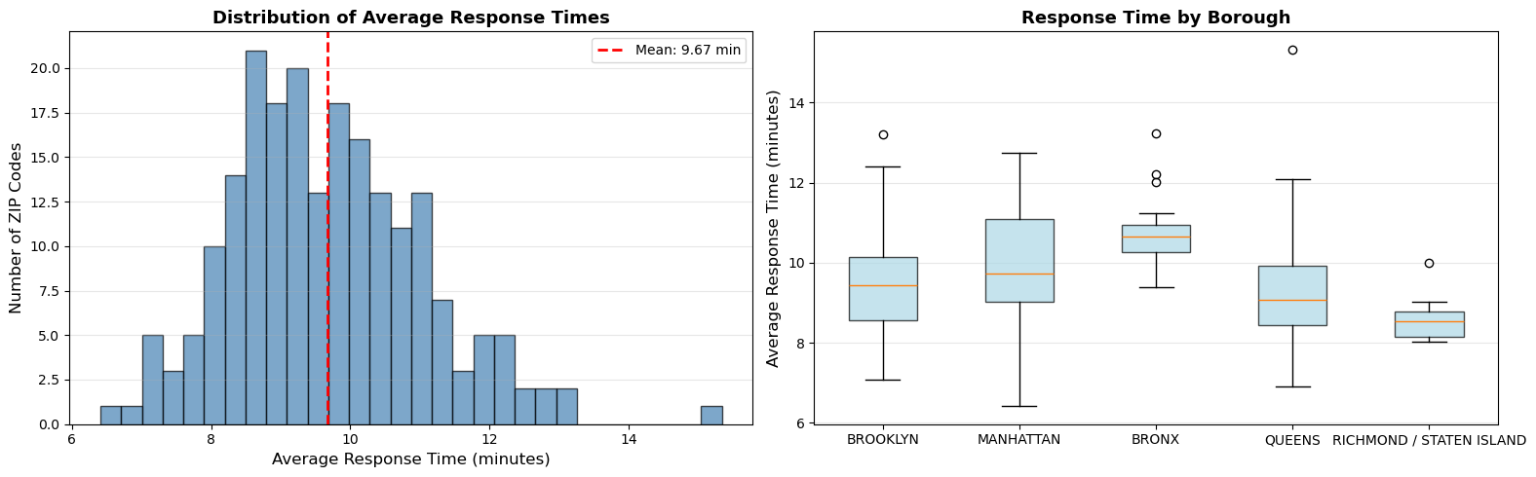
Figure 2. Distribution of average EMS response times across New York City ZIP codes (a) and comparison of ZIP-level average response times by borough (b), 2019–2024.
Next, we retrieve 2022 ACS ZIP-code indicators and construct key socioeconomic and racial measures such as poverty, unemployment, educational attainment, renter share, race composition, and a neighborhood diversity index. We convert raw ACS counts into rates or shares where appropriate, such as the percentage of residents below the poverty line or the percentage of housing units occupied by renters. We also compute a simple diversity index that summarizes how evenly different racial and ethnic groups are represented within each ZIP code. These variables provide a concise description of neighborhood context and allow us to examine how slow-response areas align with broader patterns of socioeconomic disadvantage and racial composition.
We then merge the EMS aggregates, ACS indicators, and ZIP-code geometries into a single spatial dataset and engineer additional features for analysis. The merged dataset includes incidents per 1,000 residents as a measure of EMS demand relative to population size, as well as response time per incident and borough dummy variables to capture higher-level spatial structure. For spatial analysis, we attach ZIP-code polygons and construct a queen contiguity spatial weights matrix, which enables the calculation of global Moran’s I and local indicators of spatial association for both response times and neighborhood characteristics. These engineered features support both the descriptive spatial analysis and the subsequent regression and machine-learning models.
Finally, we drop leakage variables and records with missing values, construct an 80/20 stratified train–test split, and scale predictors for the logistic regression model, yielding a clean analytic dataset for both spatial and predictive analyses. We exclude variables that directly encode the outcome or that would not be available in a prospective prediction setting, to avoid inflating model performance. We then restrict the sample to ZIP codes with complete information on EMS and ACS variables and standardize continuous predictors for the logistic regression to improve numerical stability and interpretability of coefficients. Tree-based models are trained on the same set of predictors without scaling. Through this sequence of cleaning, integration, and feature engineering steps, we obtain a consistent, spatially explicit dataset that underpins the results presented in the following sections.

Part A – Logistic Model:

Logistic regression is a statistical classification method that predicts the probability of a binary outcome (e.g., yes/no or 0/1). In this project, the model was used to predict whether a ZIP code experiences a slow EMS response time (>10 minutes). The advantages of logistic regression are that it is highly interpretable, computationally efficient, and can be regularized to reduce overfitting. However its limitations are that it assumes linear relationships and cannot determine nonlinear relationships or interactions and it is sensitive to multicollinearity.

For feature selection, we removed variables known to cause data leakage or contribute no predictive value. This included geographic identifiers (ZIPCODE, GEOID20), raw latitude/longitude coordinates, and the raw LISA/Gi* cluster labels. We also performed several feature-engineering steps, creating variables such as incidents_per_1000 (call volume per capita), response_time_per_incident, is_hotspot (binary hotspot indicator), and borough_encoded (boroughs converted into numeric codes). To examine feature importance, we ranked the logistic regression coefficients and visualized the top 20 features (Figure. X). This allowed us to identify which sociodemographic or spatial characteristics were most strongly associated with slow EMS response times.

Model training incorporated RandomizedSearchCV with a 5-fold cross-validation, testing across L1 vs L2 penalties, multiple C values, three solvers and up to 1000 iterations. The best model used L1 regularization via the saga solver. The logistic regression performed well, achieving a training AUC of 0.898 and a test AUC of 0.853, indicating strong generalization and no significant overfitting.

Our logistic model results show that the training AUC was 0.898 and the test AUC was 0.853. This indicates that there was no major overfitting and this model shows a strong performance. Figure 3. and Figure 4. visualize the performance as a confusion matrix and ROC curve. The results indicate that the model can distinguish between fast and slow response 85% of the time.
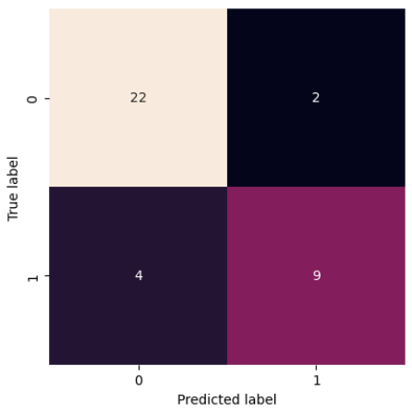
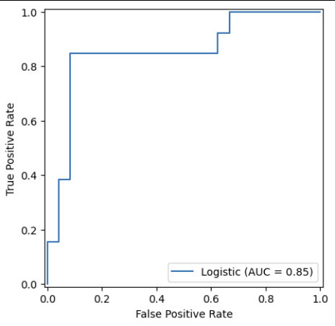

Figure 4. ROC Curve for Logistic Regression
Figure 3. Confusion Matrix for Logistic Regression

We also created a coefficient plot that displays the top 20 feature importance The values to the right indicate that those factors increase the probability of slow emergency response while the values to the left indicate that those factors decrease the probability of a slow response. Overall the results show that higher percentages of multiracial residents, renter rate, neighborhood diversity, and graduate rate tend to increase the probability of risk of slow response while higher median gross, percentage of white residents and more total households decrease the risk of slow response.

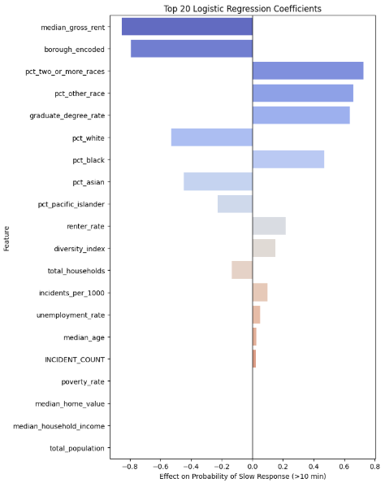
Figure 6. Coefficient Plot Showing the Top 20 Feature Importance

Part B – Non-Logistic Model
A non-logistic regression model used for nonlinear algorithms, tree-based methods, or ensemble techniques that can capture more complex relationships in the data. In this project, we used two non-logistic models, including the Gradient Boosting Classifier and the Random Forest Classifier. Both models were used to forecast if a ZIP code would experience a delayed EMS response time (>10 minutes).

The Gradient Boosting Classifier is an ensemble learning method that builds decision trees sequentially, where each new tree attempts to correct the errors made by previous trees. By learning from residuals at every iteration, Gradient Boosting is able to model complex, nonlinear relationships and capture subtle interactions between features that simpler models, such as logistic regression, often miss. In this project, Gradient Boosting demonstrated strong predictive performance, which achieves a perfect training AUC of 1.0 and a high test AUC of 0.907. It indicates that the model can correctly distinguish fast-response versus slow-response ZIP codes approximately 91% of the time. Although the perfect training AUC suggests a degree of overfitting, the model still generalized well to unseen data after hyperparameter tuning using RandomizedSearchCV with five-fold cross-validation. One major advantage of Gradient Boosting is its ability to distribute importance across a wide range of socioeconomic and spatial variables, which provides a more nuanced understanding of which community characteristics contribute to delayed EMS response. However, the model is computationally intensive and can be sensitive to noisy features or poorly chosen hyperparameters, which makes careful tuning essential.

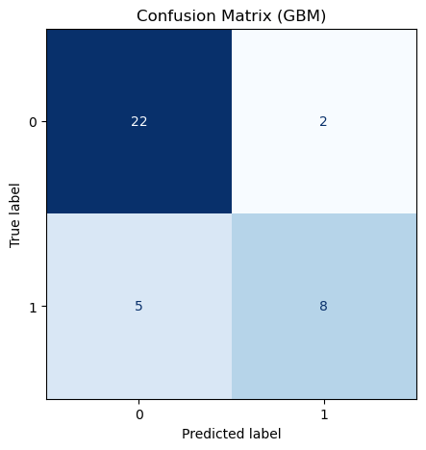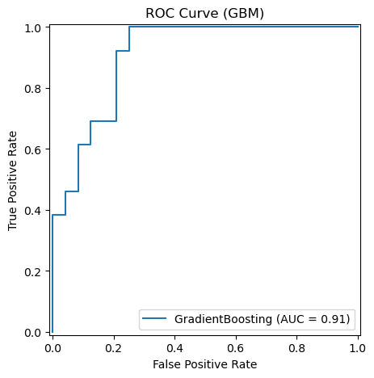

Next, the Random Forest Classifier is another nonlinear ensemble method, but unlike Gradient Boosting, it builds a large number of decision trees in parallel using bootstrap sampling and random feature selection. The final prediction is obtained through majority voting across all trees, which makes Random Forest highly robust, stable, and less prone to overfitting compared to individual decision trees. In this analysis, Random Forest also achieved strong results, with a training AUC of 1.0 and a test AUC of 0.853. While slightly lower than the Gradient Boosting model, the performance still reflects solid discriminative ability, correctly classifying approximately 85% of ZIP codes as fast or slow response zones. Random Forest's key advantage is its resilience to noisy data and multicollinearity, as well as its ability to handle high-dimensional feature sets without requiring extensive preprocessing. However, Random Forest tends to concentrate importance on a smaller set of dominant predictors, which may limit interpretability relative to Gradient Boosting. Additionally, because the model relies on averaging many trees, the probability estimates can sometimes be less calibrated compared to methods like Gradient Boosting. Despite these limitations, Random Forest served as a strong complementary model and provided consistent, reliable performance across the dataset.
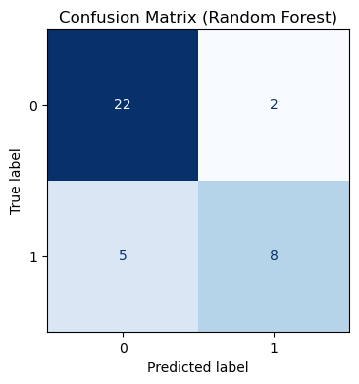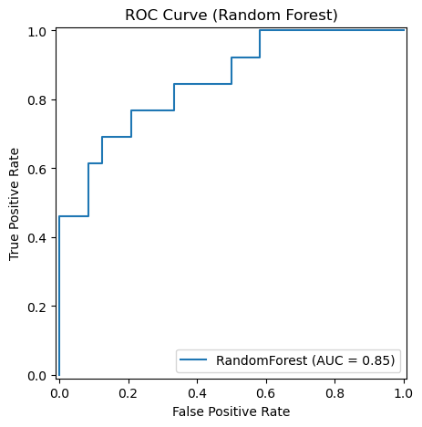

Besides that, the feature importance analysis derived from the Gradient Boosting and Random Forest models indicates that race and ethnicity variables, including the proportions of Asian, Black, other racial groups, and Hispanic residents, are among the strongest predictors of delayed EMS response times. Although both models generally align in terms of which factors are most influential, Gradient Boosting distributes importance more evenly across a wider range of socioeconomic and spatial characteristics, whereas Random Forest assigns greater weight to a smaller set of dominant predictors, particularly percent Asian and percent Black. Taken together, these findings suggest that delayed emergency response performance is shaped by a complex interplay of demographic, socioeconomic, and geographic factors, underscoring the value of nonlinear modeling approaches in capturing the multidimensional nature of EMS disparities.
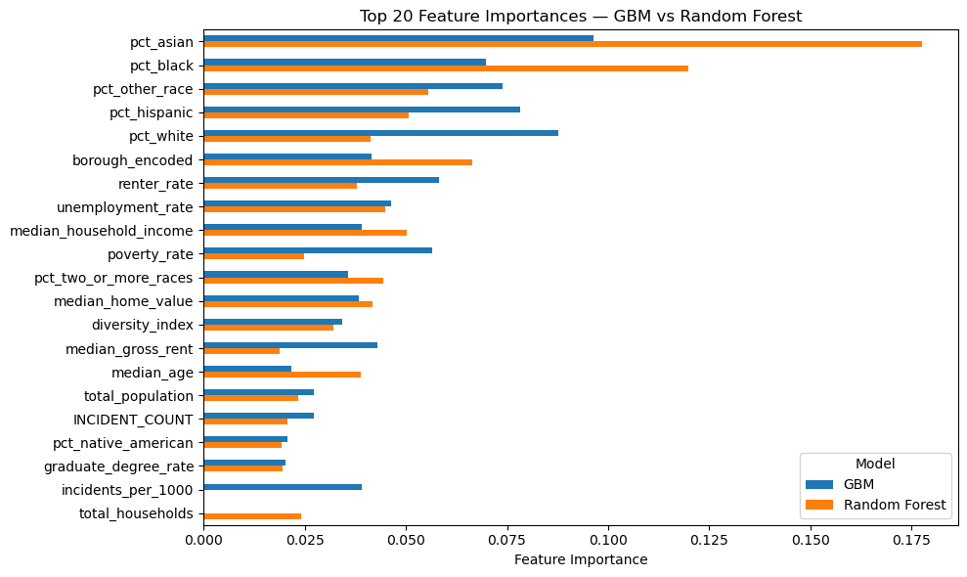
Based on the comparative analysis, Gradient Boosting emerges as the more suitable model for predicting delayed EMS response times. While Random Forest offers stable performance and strong handling of high-dimensional data, its lower test AUC and reliance on a narrower set of dominant features limit its ability to fully capture the complexity of the problem. Gradient Boosting, with a higher test AUC of 0.907 and a more distributed use of socioeconomic and spatial predictors, provides better discriminative ability and deeper insight into the drivers of EMS delays. Although it shows mild overfitting, cross-validation mitigates this concern, making Gradient Boosting the preferred model for identifying high-risk ZIP codes.

Discussion & Business Interpretation
A comparison of the two modeling approaches, logistic regression and the Gradient Boosting Classifier, demonstrates that both models contribute valuable insights into the determinants of EMS response performance, yet they differ substantially in predictive capability and flexibility. Logistic regression provides a clear and interpretable framework for understanding how individual predictors relate to the likelihood of delayed response times. Its performance in this project, reflected in a test AUC of 0.853, indicates that it is generally effective at distinguishing between fast- and slow-response ZIP codes when the underlying relationships are relatively linear and additive. However, logistic regression is inherently limited in its ability to model nonlinear interactions and complex dependencies across socioeconomic and spatial variables. The Gradient Boosting model addresses these limitations by learning patterns in an iterative, residual-correcting manner, which enables it to capture subtle interactions that logistic regression cannot. As a result, it is reflected in its higher test AUC of 0.907, which suggests stronger generalization and more precise risk identification.

The feature importance results further highlight these differences. While logistic regression emphasizes predictors such as renter rate, graduate degree rate, and neighborhood diversity, Gradient Boosting uncovers a more intricate set of influential factors and distributes importance across a broader collection of demographic and socioeconomic attributes. It suggests that delayed EMS response emerges from complex neighborhood contexts rather than isolated predictors, and nonlinear models are better suited to account for this complexity.

When communicating these findings to a business or operational stakeholder, the distinction between the models can be conveyed without relying on technical performance metrics. Logistic regression offers a straightforward, easy-to-understand explanation of risk factors, but its simplicity may cause it to overlook neighborhoods where risks arise from more nuanced combinations of characteristics. In contrast, Gradient Boosting behaves more like a sophisticated pattern-recognition system that identifies not only the obvious high-risk ZIP codes but also the less apparent ones where multiple small factors combine to elevate response times. In practical terms, it means that Gradient Boosting provides a more complete and reliable picture of where EMS delays are likely to occur, which allows decision-makers to prioritize interventions and allocate resources with greater confidence.

 | Logistic Regression | Gradient Boosting Classifier | Random Forest Classifier
AUC for Training | 0.898 | 1.00 | 1.00
AUC for Testing | 0.853 | 0.907 | 0.850

